Orange Park Eye Center

Advanced Wellness Screening Options

Our doctors recommend the following two screening tests prior to your eye exam

In order to provide the most comprehensive view of all layers of the eye, our doctors recommend the following state-of-the-art advanced imaging technology. Both of these tests provide the most thorough view of the eye and surrounding tissues. This provides the best opportunity to detect ocular diseases and conditions earlier than ever before. The tests are painless. Although dilation is not needed to perform either of these tests, the doctor may still wish to dilate your eyes as part of your exam – they will discuss this with you. Early detection and treatment of disease might save your sight!

Zeiss Cirrus OCT screening Scan Optomap Retinal Screening Photo
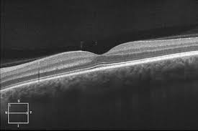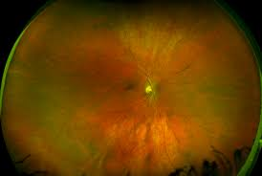
• 3D cross-sectional scan of the retina • External view of the retina from above
• Detailed layer-by-layer view of the retina • Images can be magnified to 60x
• Images stored for comparison over time • Images stored for comparison over time

Both of these instruments assist in the earliest detection and screening for:
Macular degeneration Glaucoma Retinal detachments
Diabetic changes Medication side effects High blood pressure damage
Macular edema Retinal scars Vitreous detachments
Optic nerve disease Nevus (freckle) Melanoma and other cancers

These tests are not covered by insurance: Screening fees are due at the time of service

q Yes, I want both retinal photography and OCT screening exams for $59.
q Yes, I only want a retinal photography screening exam for $39.
q Yes, I only want an OCT screening exam for $39.
q No, I elect to decline retinal photography and OCT screening exams.

_______________________________________________ ___________________________
Patient or Legal Guardian Signature Date

